Create ACL for Institution Details
Project Development Phase | 5 of 7
Project | Script-Controlled ACL - Restrict Record Access Based on Field Value
Date / Team ID | 1 October 2026 | Team ID: [enter team ID]

Purpose
Add a dedicated create ACL for the Institution Details table. This controls which users can insert records; the Branch rule for an unsaved record needs special handling.

Create ACL configuration
Setting | Value
Type / Operation | Record / create
Name | Institution Details [u_institution_details] / --None--
Decision type / Active | Allow If / selected
Admin overrides | Selected for the project administrator outcome.
Requires role | bb2

- Elevate to security_admin and create a new record ACL.
- Set Operation to create, select the Institution Details table, and enable Active and Admin overrides.
- Add bb2 as the required role. The supplied ACL screenshot confirms bb2 and shows Advanced off, so it does not demonstrate a scripted Branch check. Save and verify that only the intended table is selected.
- Test creating a Branch=EEE record as EEE User and as an administrator.

Branch validation for new records
Target policy: create only EEE records through the EEE project account. The supplied Create ACL screenshot is role-only (bb2; Advanced off); it does not show this Branch check. A script such as the one below expresses the target only when Branch is available:
answer = current.getValue('u_branch') == 'EEE';

Important platform behavior ServiceNow documents that fields on a new record can be empty during create-ACL evaluation. A create ACL that checks Branch may therefore deny the form or insert before the submitted value is available. Verify this on your instance. For a reliable insert guard, keep the create ACL role-gated with bb2 and enforce Branch=EEE in a before-insert server-side validation rule; test API inserts as well as the form.

Acceptance checks
Test | Expected result | Actual / status
EEE User with bb2 creates Branch EEE | Allowed if the instance exposes the value at ACL evaluation; otherwise blocked until server-side validation is configured. | To test
EEE User attempts Branch ECE or CSE | Denied by the server-side Branch validation rule. | To test
User without bb2 attempts create | Denied by the ACL. | To test
Administrator creates a sample record | Allowed when Admin overrides is selected. | To test

References
Project walkthrough: YouTube demonstration
ServiceNow documentation: Configure an ACL | ACL types | Explore ACLs

Screenshot evidence and implementation alignment
Evidence finding: The dedicated Create screenshot confirms a table-level create ACL with required role bb2, Active, Allow If, and Admin overrides. Advanced is off, so the screenshot does not show a Branch field script. The proposed create guard remains unverified.
Create record ACL form: table u_institution_details, operation create, Allow If, Active, Admin overrides, and required role bb2. Advanced scripting is not enabled in this capture.
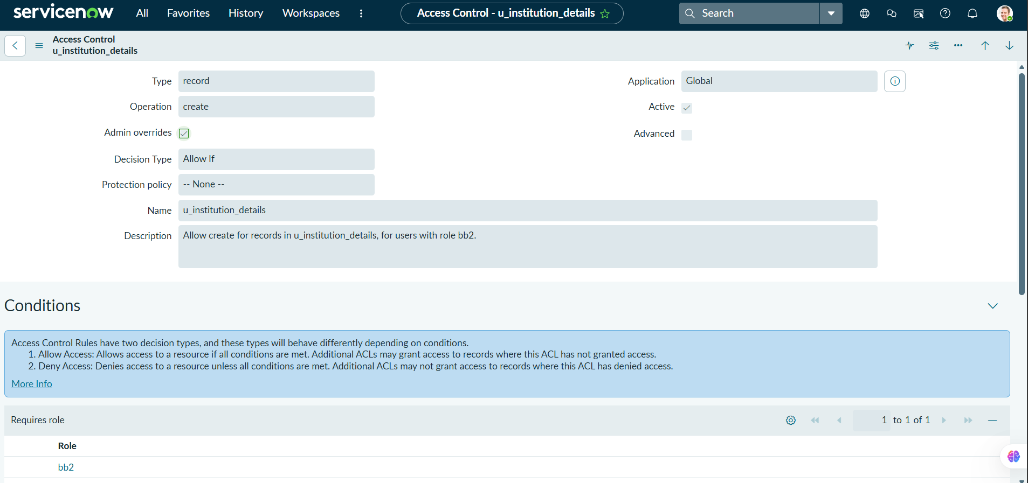

ACL conditions screenshot shows the bb2 role for the create permission.
